**How to install MongoDB on Windows**

1. Download MongoDB community server 4.2.3 from the following URL:

https://fastdl.mongodb.org/win32/mongodb-win32-x86_64-2012plus-4.2.3-signed.msi

1. Open the installation file. Accept all default options. Note that you do **NOT** need to install MongoDB Compass.

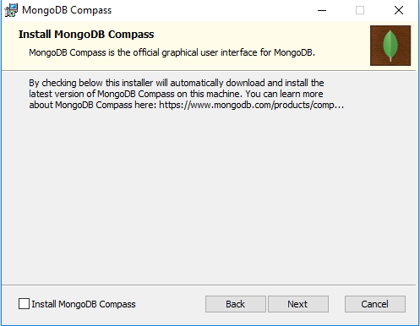

1. After the installation, you might be asked to reboot your PC. After that the MongoDB Service should be running in the background.
2. To begin using MongoDB, you will need connect mondb.exe shell to the running service. From Windows explorer, run the following file:

C:\Program Files\MongoDB\Server\4.2\bin\mongo.exe

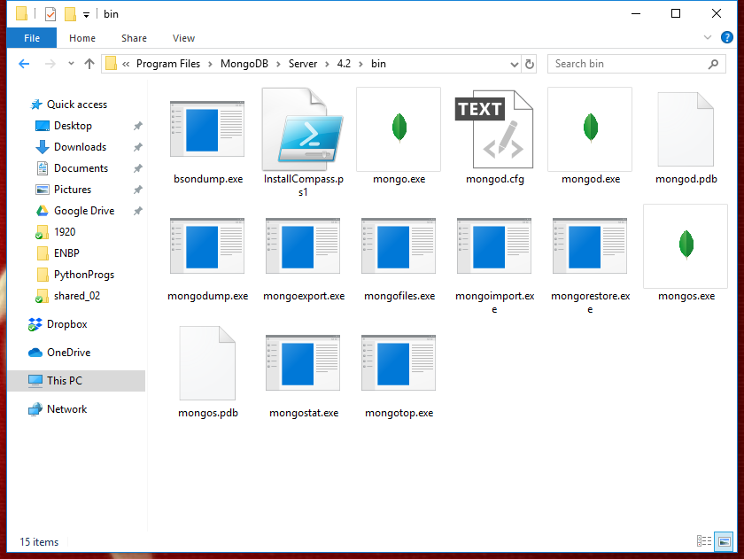

After that, the following MongoDB shell should be launched as follows:

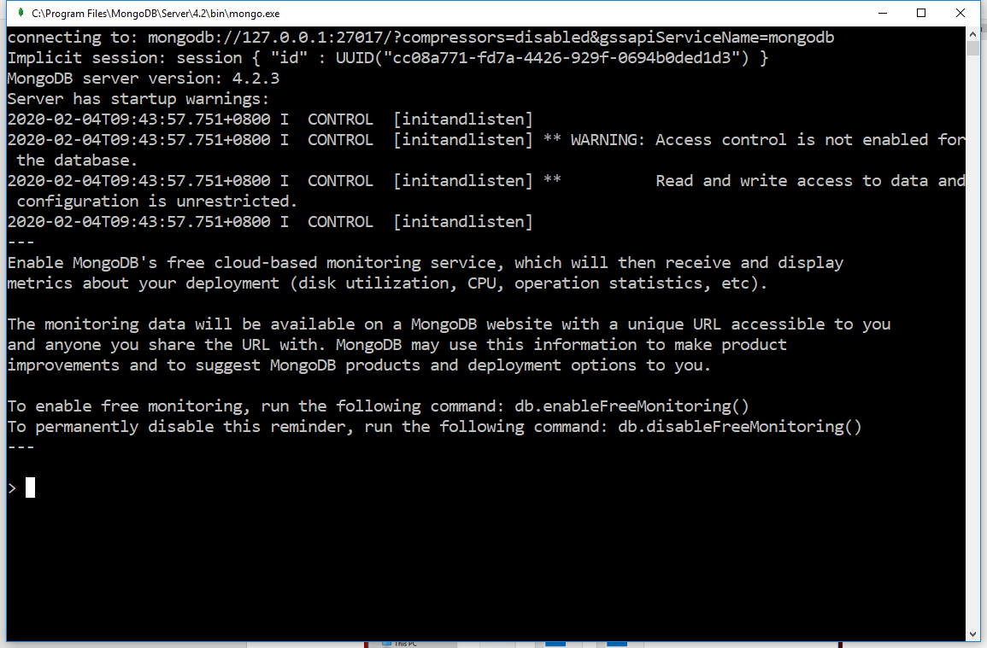

Enter the following shell command to test if the server is running:

> **show dbs**

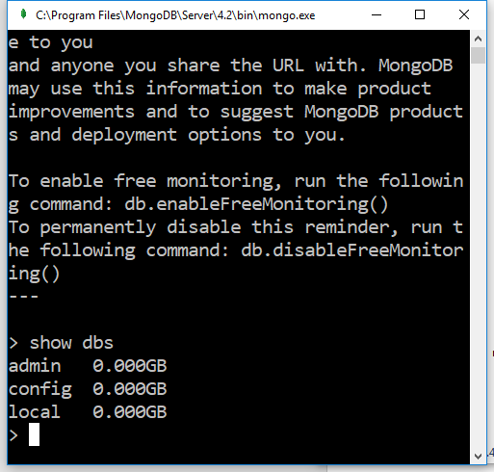

**How to install MongoDB on Mac**

1. Install Homebrew brew package (if you do not already have it) by opening Terminal and issue the following command:

|  |
| --- |
| **/usr/bin/ruby -e "$(curl -fsSL https://raw.githubusercontent.com/Homebrew/install/master/install)"** |

1. Tap the MongoDB Homebrew Tap by issuing the following command from Terminal:

|  |
| --- |
| **brew tap mongodb/brew** |

1. Install MongoDB:

|  |
| --- |
| **brew install** [**mongodb-community@4.4**](mailto:mongodb-community@4.4) |

1. To run MongoDB (i.e. the mongod process) as a macOS service, issue the following:

|  |
| --- |
| **brew services start** [**mongodb-community@4.4**](mailto:mongodb-community@4.2) |

1. To begin using MongoDB, connect a mongo shell to the running instance. From a new terminal, issue the following:

|  |
| --- |
| **mongo** |

1. Enter the following command (in mongo Terminal) to test the running MongoDB service:

|  |
| --- |
| > **show dbs** |

